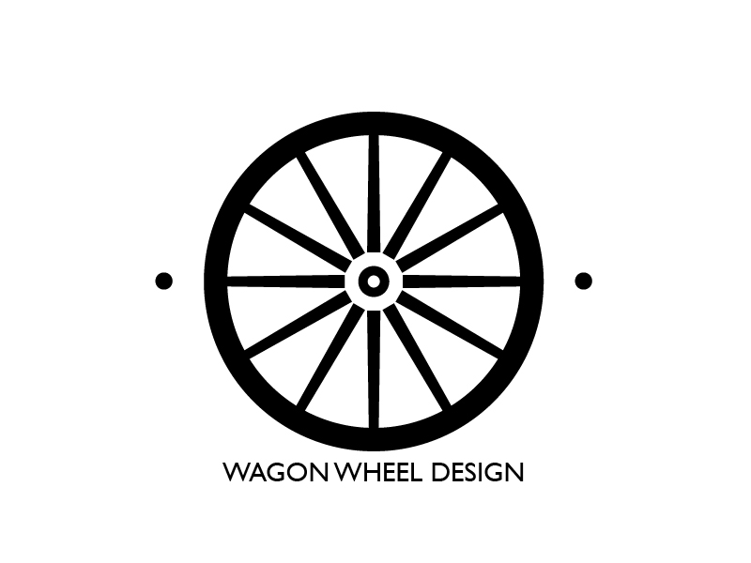

Tealuxe Competitive Analysis

Addison Hanson

Ripley Walters

Manager – Web Content

Tealuxe

Re: Comparative Assessment of Competitor Websites

Dear Mr. Walters February 13, 2018

Thank you for trusting Wagon Wheel Design with this important project. Attached is my report on the comparative assessment of Tealuxe’s website as compared to three of your competitors.

Overall, Tealuxe has a lot of work to do in order to bring their website into the 21st century and provide a comparable experience to their users that other tea websites provide. The simplistic and arcane design of tealuxe.com is very obvious from the moment a user arrives at the home page. Wagon Wheel Design would be a great option if you decide to fully revamp the websites look.

Attached is a written report outlining specific design improvements that Tealuxe should make, and analyzing some different ways that competitors accomplish the same function. With these improvements, Tealuxe will take a huge step in improving their customer’s experience, and hopefully increase their market share.

Sincerely,

Addison Hanson

User Interface and User Experience Designer

Wagon Wheel Design

65 Bromfield Rd

Somerville MA, 02144

Cell: (610)-324-0102

Email: [Addison.hanson@tufts.edu](mailto:Addison.hanson@tufts.edu)

Tealuxe Comparative Assessment:

Among the four websites that we analyzed, Tealuxe, Twinings, T2, and TeaPigs, Tealuxe had by far the *worst* user experience and design. Each of the competitor’s websites have sleek modern looking designs that entice users to make purchases and learn more about tea and the tea industry. There are some specific, actionable changes that Tealuxe can make in order to make their website more visually appealing and easier to use.

When compared to its competitors, the first thing that stands out on the Tealuxe webpage is the lack of a consistent and coordinated color scheme. This makes the screen really hard to navigate. Using a consistent color scheme can help establish link hierarchy as well as help the user get to where they want to go as quickly and efficiently as possible. The navigation bar at the top of the screen is the same width as the secondary navigation bar below it. This creates some ambiguity in terms of which bar to use to navigate. Moving down the home page, there is an introduction to the company statement followed by a grid of pictures of tea. It seems odd that there is an entire paragraph devoted to the history of the company in such prime screen “real-estate” when there is also an About Us page. Better use of this space would be either outlining current deals or sales happening, or outlining the different tea options that Tealuxe offers.

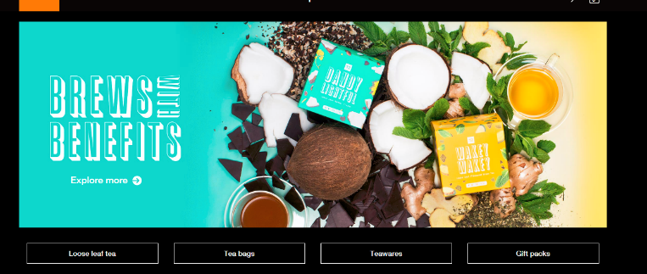Here is the same main screen from the T2 website. They use this space to promote their healthy teas and then have broad category buttons below, allowing users to quickly and easily navigate to the tea that they want. Tealuxe has a similar function with their grid of tea types, but the categories that Tealuxe uses are not broad enough to be useful. They have a button for “Black Tea” and then a different button for “Flavored Black Tea” right next to it. Those two can be lumped into the same primary button and combining some of the groups like that will free up screen space, streamline the user experience, and eliminate essentially redundant features.

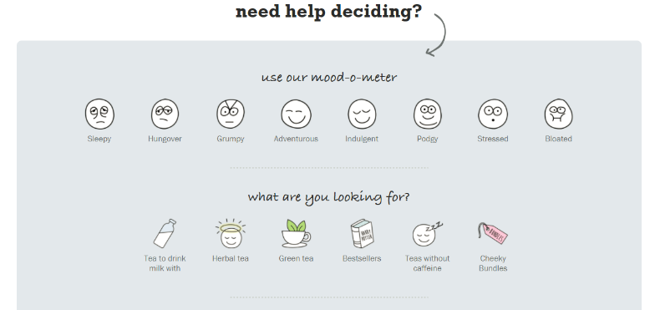One of the big things that Tealuxe is lacking is a clear conceptual model of their users. Exercises like making persona’s might help Tealuxe refine their user experience and help them catch a lot of these issues. There are a limited number of user types coming to a tea ordering website. There are “experienced” tea users who know exactly what they want and want to spend the least amount of time possible on the site to order tea. Then there are users who are interested in learning more about tea and can be catered to by having a matching survey like on the TeaPigs website. These users are looking to learn more about tea and if they have a positive experience on the Tealuxe website, there is an opportunity to increase their customer base. The third group is people who know nothing about tea and are ordering gifts for relatives and friends. Many of Tealuxe’s competitors have very obvious links to gift packages and gift certificate pages.

All three of these groups should be considered and Tealuxe should have features on their website that are helpful to each group. First, an experienced tea drinker should be able to search and quickly checkout, placating Tealuxe’s existing customer base. Secondly, a first time user of the website should be able to learn more and get matched with the tea that is right for them, thus expanding Tealuxe’s customer base. Thirdly, gift buyers should be able to purchase curated gift packages for their friends, which probably won’t add another loyal customer to the base, but is another source of income that currently Tealuxe does not get.

Besides adding features and increasing usability, Tealuxe’s website is in desperate need of a new user interface. The current page looks straight out of 2003, and compared to some of their competitors, Tealuxe’s page looks sloppy and not well maintained. Current design trends call for a bold color scheme, flat buttons, a floating navigation bar that stays at the top of the screen despite scrolling, and bright visuals promoting deals and new teas. By implementing some of these UI changes, Tealuxe can work on attracting new customers and will have a better shot of fairly competing with other companies.

Summary of Recommendations:

Global:

* Create Customer personas
* Update site map to reflect persona’s needs
* Create a unified and modern color scheme
* Take new pictures of your products
* Offer gift packages

Specific:

* Unify the navigation bar to include Home, Shop Tea, Learn More, About Us
* Re-code the website using ReactJS or similar framework to create a modern look and feel
* Create new promotions and sales to drive business
* Re-categorize the tea’s into easier distinguishable groups
* Talk to your customers and find out what they want and implement some of those suggestions

|  |  |  |  |  |  |  |  |  |  |
| --- | --- | --- | --- | --- | --- | --- | --- | --- | --- |
|  |  | Tealuxe | | Twinings | | T2 | | TeaPigs | |
| Attribute | Weight | Rating | Weighted Score | Rating | Weighted Score | Rating | Weighted Score | Rating | Weighted Score |
|  |  |  |  |  |  |  |  |  |  |
| Conceptional Design | 5 | 4 | 2 | 7 | 3.5 | 9 | 4.5 | 7 | 3.5 |
| UI Structure | 10 | 2 | 2 | 7 | 7 | 9 | 9 | 8 | 8 |
| Usefullness | 25 | 7 | 17.5 | 8 | 20 | 10 | 25 | 10 | 25 |
| Visual Appeal | 10 | 2 | 2 | 5 | 5 | 10 | 10 | 7 | 7 |
| Emotional Engagement | 10 | 1 | 1 | 7 | 7 | 8 | 8 | 9 | 9 |
| Straightfoward Design | 5 | 3 | 1.5 | 8 | 4 | 8 | 4 | 8 | 4 |
| Use of Color/Visuals | 10 | 1 | 1 | 4 | 4 | 9 | 9 | 8 | 8 |
| Shopping Experience | 15 | 1 | 1.5 | 7 | 10.5 | 9 | 13.5 | 9 | 13.5 |
| Special Options | 5 | 1 | 0.5 | 6 | 3 | 9 | 4.5 | 8 | 4 |
| Modern Look | 5 | 0 | 0 | 6 | 3 | 10 | 5 | 7 | 3.5 |
|  |  |  |  |  |  |  |  |  |  |
| Score | 100 |  | 29 |  | 67 |  | 92.5 |  | 85.5 |
| Rank |  |  | 4 |  | 3 |  | 1 |  |  |